**Gesture Volume Control project using opencv in windows**

The Gesture Volume Control project using Python and OpenCV on Windows is an innovative application where you can control the volume of your system using hand gestures detected through your webcam. This project leverages computer vision techniques to detect and track hand movements, translating specific gestures into volume control commands.

### Project Overview

The project uses a webcam to capture live video, processes the video frames to detect hand landmarks, and interprets the distance between specific landmarks (e.g., thumb and index finger) as a command to increase or decrease the volume.

### Required Components and Libraries

1. **Python**: The programming language used for developing the project.
2. **OpenCV**: For capturing video and image processing.
3. **Mediapipe**: A machine learning library by Google that provides pre-trained models for detecting and tracking hands.
4. **Numpy**: For numerical calculations.
5. **PyCaw (Python Core Audio Windows)**: A Python library for controlling the system volume on Windows.

**Outline of the Project :**

1. **Install Necessary Libraries**
2. Capture Video from Webcam
3. **Hand Detection using Mediapipe**
4. Calculate Distance between Fingers
5. Map Gesture to Volume Control

### Explanation:

**Volume Control Setup**:

* 1. The script uses PyCaw to interface with the system's audio API and control the volume. The range of volume levels is fetched from the system, and SetMasterVolumeLevel() adjusts the volume based on the distance between your thumb and index finger.

**Hand Tracking with Mediapipe**:

* 1. The script uses Mediapipe to detect hand landmarks. Specifically, it tracks the tips of the thumb (landmark 4) and index finger (landmark 8).
  2. The distance between these two points is calculated using numpy's linalg.norm function.

**Volume Mapping**:

* 1. The distance between the fingers is mapped to a volume level using np.interp(). The volume is adjusted in real time based on the distance between the thumb and index finger.
  2. A visual volume bar and percentage are displayed on the screen to give you feedback on the current volume level.

**User Interface**:

* 1. Circles and a line are drawn between the thumb and index finger to visually represent the gesture being tracked.
  2. A green rectangle represents the volume bar, with its height corresponding to the current volume level.

**CODE EXPLAINATION :**

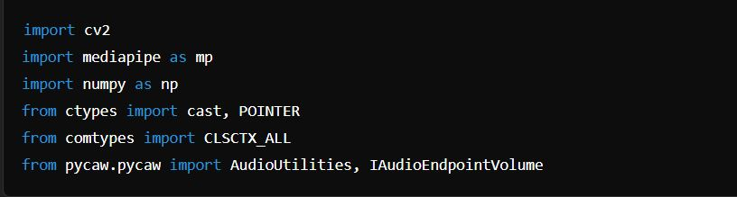

* **Imports**: This section imports the necessary libraries.

#### Mediapipe Initialization :

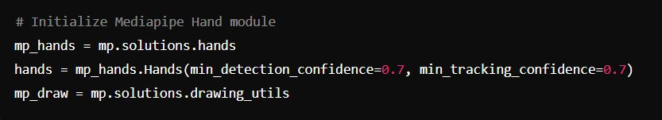

**Mediapipe Hand Module**:

* mp.solutions.hands: Provides hand detection functionality.
* hands = mp_hands.Hands(...): Creates a Hands object with specific confidence thresholds for detection and tracking.
* mp_draw = mp.solutions.drawing_utils: Utility to draw hand landmarks and connections.

****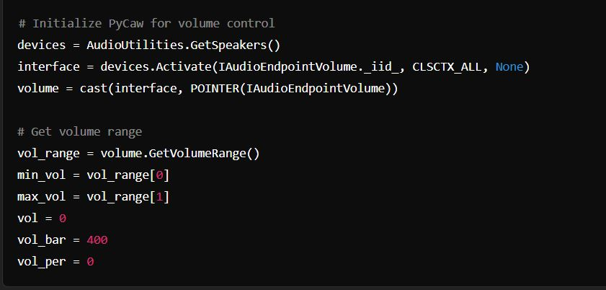**PyCaw Initialization **:****

* **PyCaw Setup**:
  + AudioUtilities.GetSpeakers(): Gets the default audio playback device.
  + devices.Activate(...): Activates the audio device interface to control volume.
  + volume = cast(...): Casts the interface to the IAudioEndpointVolume type for volume control.
  + volume.GetVolumeRange(): Retrieves the minimum and maximum volume levels.
  + Variables vol, vol_bar, and vol_per are initialized to track volume and its graphical representation.

#### Video Capture and Processing :

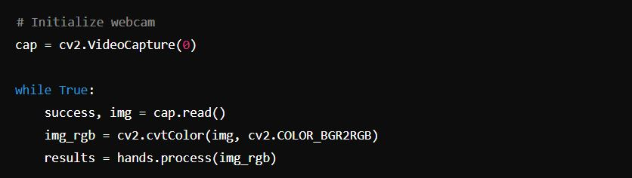

* **Webcam Initialization**:
  + cap = cv2.VideoCapture(0): Initializes video capture from the default webcam.
  + cap.read(): Captures a frame from the webcam.
  + cv2.cvtColor(img, cv2.COLOR_BGR2RGB): Converts the captured frame from BGR (default OpenCV format) to RGB (required by Mediapipe).

#### Hand Detection and Volume Adjustment :